# Fluxys Guide: Details page layout

## Big title – full width

**Example:**



**Copy this code to get this element:**

|  |
| --- |
| <**h2 class="title-section-big"**>Replace text</**h2**> |

## Paragraph - full width

**Example:**

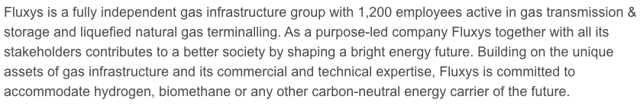

**Copy this code to get this element:**

|  |
| --- |
| <**p class="text-full-width"**>Replace text</**p**> |

## Title with background

**Example:**



**Copy this code to get this element:**

<**img src="/media/images/campaign/vorm5-titels.png"**>

|  |
| --- |
| <**h3 class="title-section-with-background"**>  <**span class="title-section-with-background-inner"**>  <**img src="/media/images/campaign/vorm5-titels.png"**>  Replace text  </**span**>  </**h3**> |

## Paragraph next to title with background

**Example:**

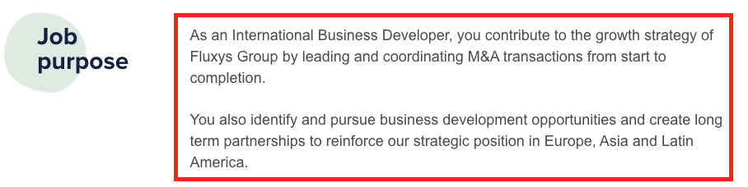

**Copy this code to get this element:**

|  |
| --- |
| <**p class="text-with-title"**>Replace text</**p**> |

## List and nested list next to title with background

**Example:**

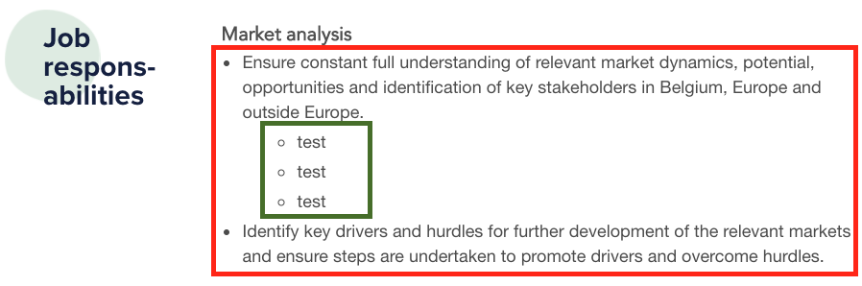

**Copy this code to get this element:**

|  |
| --- |
| <**ul class="list"**>  <**li**>Replace text</**li**>  <**li**>Replace text  /* BEGIN OF NESTED LIST – place it in a <li> </li> element*/  <**ul class="nested-list"**>  <**li**>Replace text</**li**>  <**li**>Replace text</**li**>  <**li**>Replace text</**li**>  </**ul**>  /* END OF NESTED LIST*/  </**li**>  <**li>**Replace text</**li**> </**ul**> |

## Big image background

**Example:**

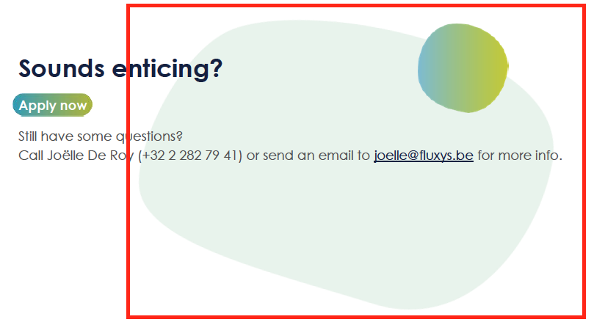

**Copy this code to get this element:**

|  |
| --- |
| <**h3 class="title-section-big big-image-background"**>Replace text</**h3**> |

## Link or element who looks like a link

**Example:**

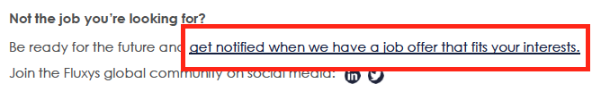

**Copy this code to get this element:**

**If it is a link with <a></a> :**

|  |
| --- |
| <**a href="**Replace text(link)>Replace text</**a**> |

**If it is a link without <a></a>, add class link-feel to the element :**

|  |
| --- |
| <span **class=”link-feel”**>Replace text</span> |

## Emphasis element with gradient

**Example:**



**Copy this code to get this element:**

|  |
| --- |
| <**span class="text-emphasis-gradient"**>Replace text</**span**> |

## Block CTA with icons

**Example:**



**Copy this code to get this element:**

|  |
| --- |
| <**p class="cta-with-icon healthy first"**>Healthy work life balance</**p**>  <**p class="cta-with-icon salary"**>Competitive salary</**p**>  <**p class="cta-with-icon opportunities"**>Learning and development opportunities</**p**> |

## Apply button

**Example:**



**Copy this code on a page with the apply button to get this element:**

|  |
| --- |
| <**p class="btn-with-gradient apply-btn" style="font-family**: **Arial**;;**"**><**span class="hide"**>**&nbsp;**</**span**></**p**> |

## Quote

**Example:**

**Copy this code on a page with the apply button to get this element:**

|  |
| --- |
| <**div class="quote"**>  <**div class="quote-inner-wrapper"**>  <**div class="quote-text-wrapper"**>  <**div class="quote-text"**>  <**img class="quote-text-decoration" src="/media/images/campaign/quote.png"** />  Replace text  </**div**>  <**div class="quote-text-person"**>  - Replace text  </**div**>  </**div**>  <**div class="quote-img-person"**>  <**img src="/media/images/campaign/picture-organic-shape.png"** />  </**div**>  </**div**> </**div**> |

## Partage : Enlever ou ajouter un rÉseau/MOYEN DE PARTAGE

Le code qui génère les icônes des réseaux sociaux se trouve dans **Branding > Bottom**.

<**a class="a2a_button_twitter"**></**a**>  
<**a class="a2a_button_facebook"**></**a**>  
<**a class="a2a_button_linkedin"**></**a**>  
<**a class="a2a_button_email"**></**a**>  
<**a class="a2a_button_whatsapp"**></**a**>  
<**a class="a2a_button_sms"**></**a**>  
<**a class="a2a_button_facebook_messenger"**></**a**>  
<**a class="a2a_dd" href="https://www.addtoany.com/share"**>...</**a**>

Il suffit d’enlever une ligne pour voir l’icône de partage disparaitre

Ci-dessous, une liste des réseaux ou moyens de partage disponibles :

<a class="a2a_button_facebook"></a>

<a class="a2a_button_twitter"></a>

<a class="a2a_button_email"></a>

<a class="a2a_button_linkedin"></a>

<a class="a2a_button_pinterest"></a>

<a class="a2a_button_reddit"></a>

<a class="a2a_button_whatsapp"></a>

<a class="a2a_button_google_gmail"></a>

<a class="a2a_button_telegram"></a>

<a class="a2a_button_tumblr"></a>

<a class="a2a_button_pocket"></a>

<a class="a2a_button_mix"></a>

<a class="a2a_button_amazon_wish_list"></a>

<a class="a2a_button_aol_mail"></a>

<a class="a2a_button_balatarin"></a>

<a class="a2a_button_bibsonomy"></a>

<a class="a2a_button_bitty_browser"></a>

<a class="a2a_button_blogger"></a>

<a class="a2a_button_blogmarks"></a>

<a class="a2a_button_bookmarks_fr"></a>

<a class="a2a_button_box_net"></a>

<a class="a2a_button_buffer"></a>

<a class="a2a_button_care2_news"></a>

<a class="a2a_button_citeulike"></a>

<a class="a2a_button_design_float"></a>

<a class="a2a_button_copy_link"></a>

<a class="a2a_button_diary_ru"></a>

<a class="a2a_button_diaspora"></a>

<a class="a2a_button_digg"></a>

<a class="a2a_button_diigo"></a>

<a class="a2a_button_douban"></a>

<a class="a2a_button_draugiem"></a>

<a class="a2a_button_dzone"></a>

<a class="a2a_button_evernote"></a>

<a class="a2a_button_facebook_messenger"></a>

<a class="a2a_button_fark"></a>

<a class="a2a_button_flipboard"></a>

<a class="a2a_button_folkd"></a>

<a class="a2a_button_google_bookmarks"></a>

<a class="a2a_button_google_classroom"></a>

<a class="a2a_button_hacker_news"></a>

<a class="a2a_button_hatena"></a>

<a class="a2a_button_houzz"></a>

<a class="a2a_button_instapaper"></a>

<a class="a2a_button_kakao"></a>

<a class="a2a_button_kik"></a>

<a class="a2a_button_kindle_it"></a>

<a class="a2a_button_known"></a>

<a class="a2a_button_livejournal"></a>

<a class="a2a_button_line"></a>

<a class="a2a_button_mail_ru"></a>

<a class="a2a_button_mastodon"></a>

<a class="a2a_button_meneame"></a>

<a class="a2a_button_mendeley"></a>

<a class="a2a_button_mewe"></a>

<a class="a2a_button_mixi"></a>

<a class="a2a_button_netvouz"></a>

<a class="a2a_button_myspace"></a>

<a class="a2a_button_odnoklassniki"></a>

<a class="a2a_button_outlook_com"></a>

<a class="a2a_button_pinboard"></a>

<a class="a2a_button_papaly"></a>

<a class="a2a_button_plurk"></a>

<a class="a2a_button_print"></a>

<a class="a2a_button_protopage_bookmarks"></a>

<a class="a2a_button_printfriendly"></a>

<a class="a2a_button_qzone"></a>

<a class="a2a_button_pusha"></a>

<a class="a2a_button_rediff"></a>

<a class="a2a_button_refind"></a>

<a class="a2a_button_sina_weibo"></a>

<a class="a2a_button_renren"></a>

<a class="a2a_button_sitejot"></a>

<a class="a2a_button_skype"></a>

<a class="a2a_button_sms"></a>

<a class="a2a_button_slashdot"></a>

<a class="a2a_button_stocktwits"></a>

<a class="a2a_button_svejo"></a>

<a class="a2a_button_threema"></a>

<a class="a2a_button_symbaloo_bookmarks"></a>

<a class="a2a_button_trello"></a>

<a class="a2a_button_tuenti"></a>

<a class="a2a_button_typepad_post"></a>

<a class="a2a_button_twiddla"></a>

<a class="a2a_button_viadeo"></a>

<a class="a2a_button_viber"></a>

<a class="a2a_button_wanelo"></a>

<a class="a2a_button_vk"></a>

<a class="a2a_button_wechat"></a>

<a class="a2a_button_wordpress"></a>

<a class="a2a_button_xing"></a>

<a class="a2a_button_wykop"></a>

<a class="a2a_button_yahoo_mail"></a>

<a class="a2a_button_yoolink"></a>

<a class="a2a_button_yummly"></a>